SECURE HOSPITAL SYSTEM
By Debesh Mishra
The purpose of this project is to develop a secure hospital system which handles various hospital related functionalities.
OVERVIEW
The application has six different roles which are: Administrator, Doctor, Hospital Staff, Lab Staff, Insurance Staff and Patient.
While signing up, the users can only be assigned the Patient role, however Admins can change the role to anything else.
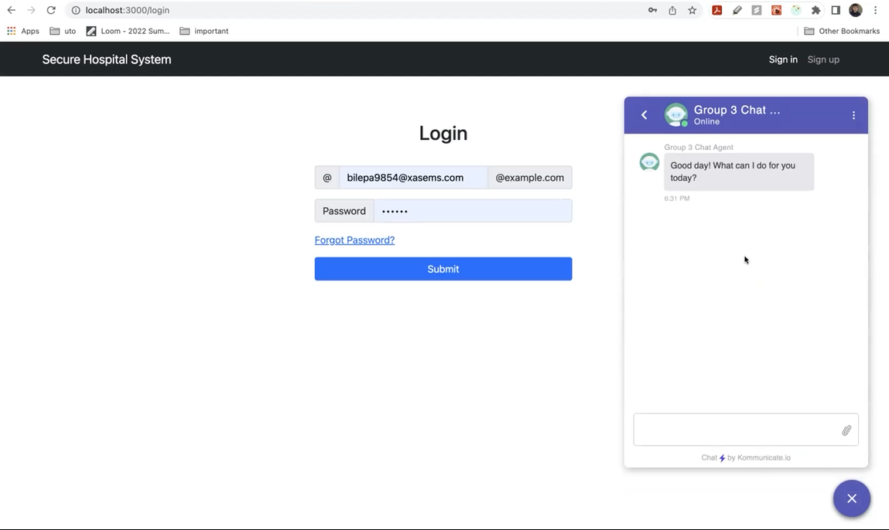
Figure 1: Login Page along with Chatbot UI

ADMINISTRATOR
The admins have access to all the functionalities that other staff members also have except the ability to create diagnosis and take appointments which only Doctors can do. In this section only the functionalities that Admin has access to will be covered and others will be covered in their own roles section.
View all Users: Admins have the ability to view all users regardless of their role as shown in the figure below. This UI is same for other roles for viewing Patients but they cannot edit the users and only Patients are in the list.
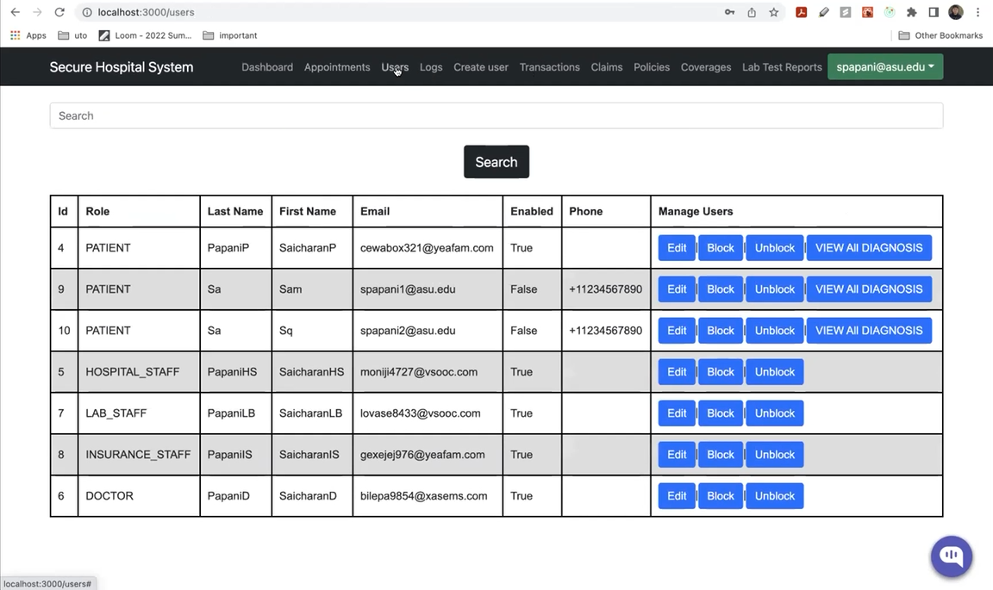
Figure 2: Admin View All Users UI
View Logs: Admins have the ability to check login logs of any user that has logged in. The date and the time of login will be logged.
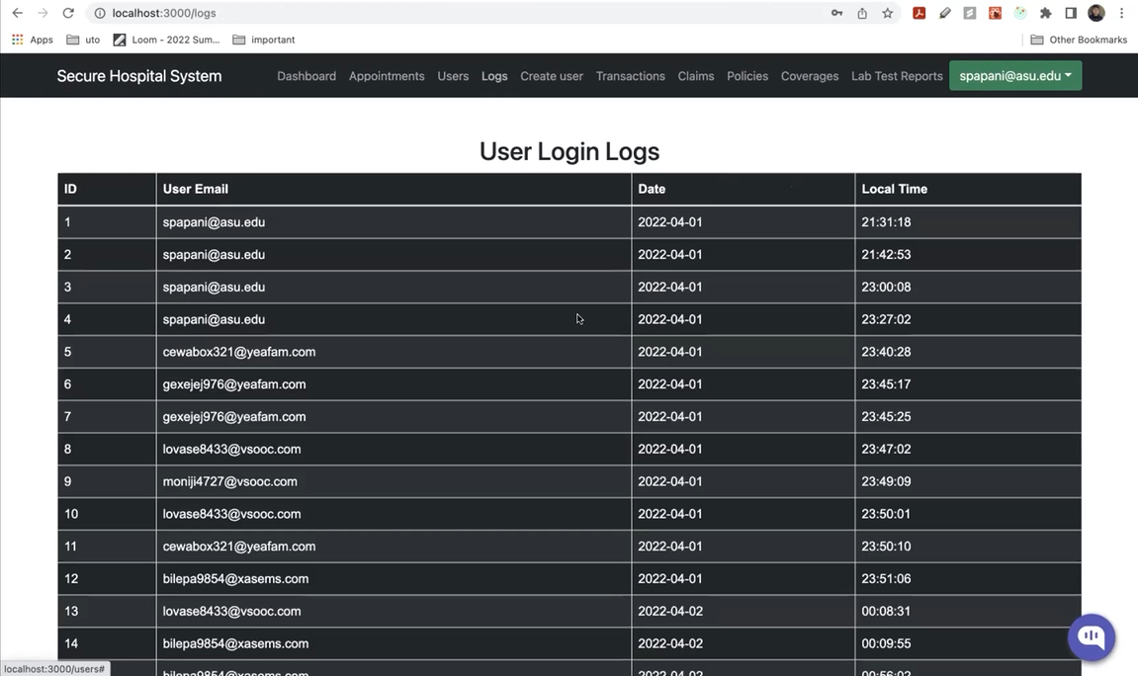
Figure 3: Admin View User Logs UI
Create new User: Admins have the ability to create a new user and assign any role to them. This UI is same during Sign Up or when Hospital Staff is trying to create a Patient. In that case, the Role field will not appear in the UI and the default Patient role will be assigned.
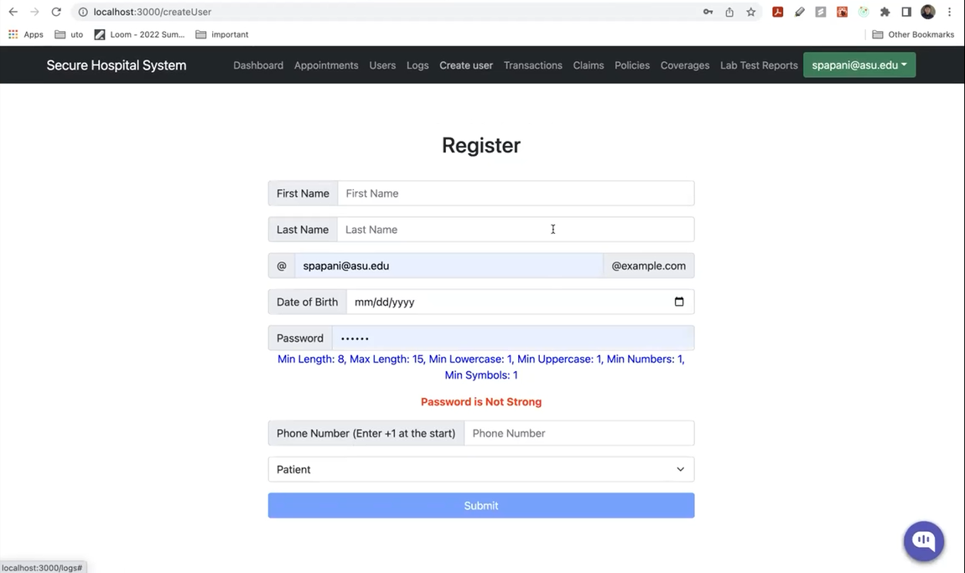
Figure 4: Create New User UI with Role visible

DOCTOR
The doctors can check their appointments, write diagnosis and prescription to their patients and also recommend lab tests.
View Appointments: In this UI, they can check their current and past appointments.
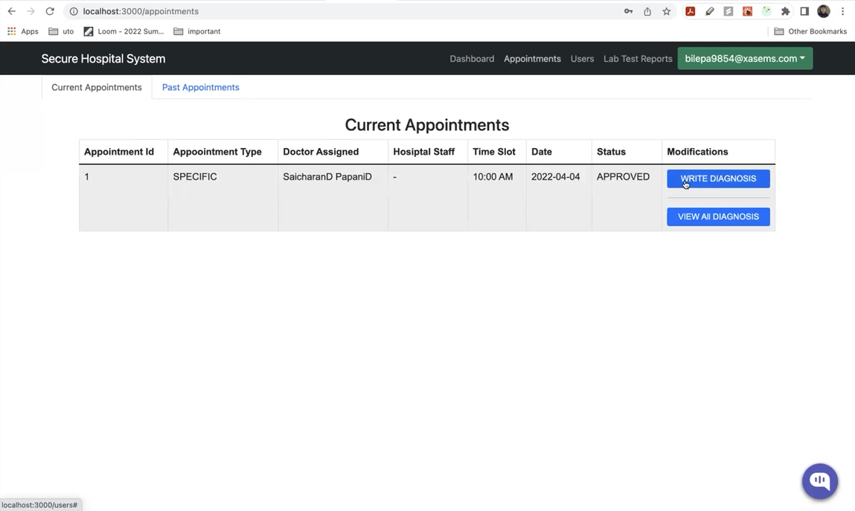
Figure 5: View all Appointments
Write Diagnosis: After clicking the button in appointment UI, they will see the diagnosis form shown below where they can write the diagnosis, prescription and recommend lab tests.
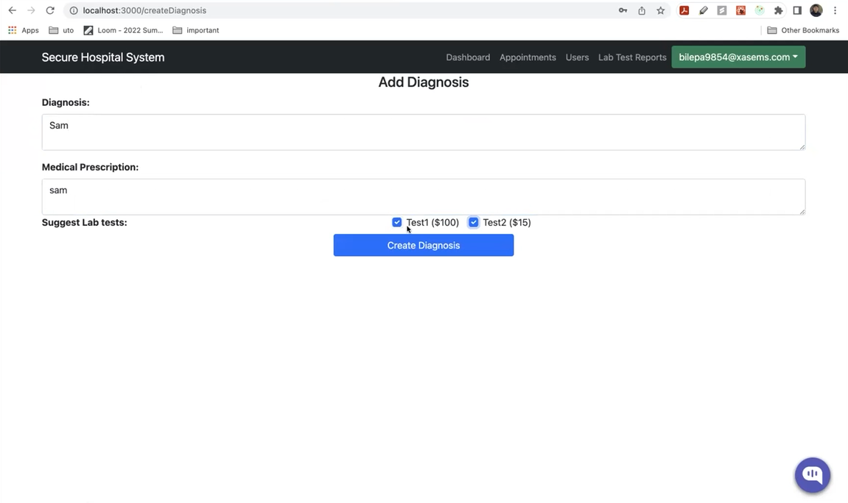
Figure 6: Writing Diagnosis

HOSPITAL STAFF
The hospital staff can approve/deny appointments, create and view patients and approve/deny transactions after appointment is completed.
Approve/Deny Appointments: The staff can approve/deny appointments raised by patient as shown below:
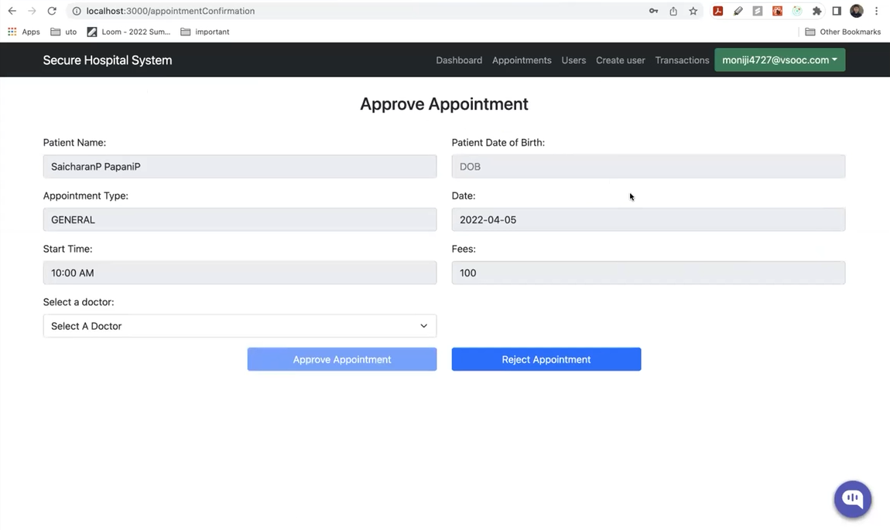
Figure 7: Approve/Deny Appointments
Approve/Deny Transactions: The staff can approve/deny transaction requests raised by the patients to pay the bill.
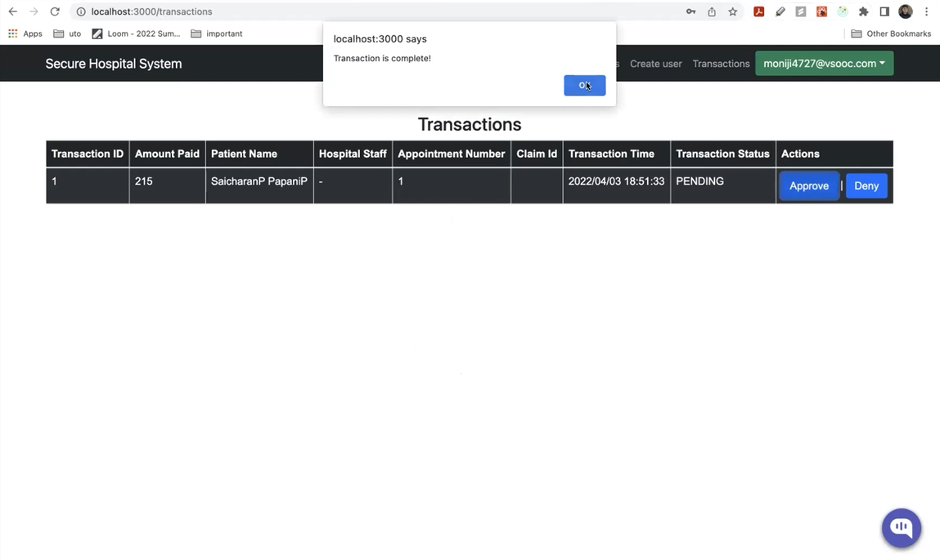
Figure 8: Approve/Deny Transactions
LAB STAFF
The lab staff can approve/deny lab test requests raised by doctor, write lab reports and create new lab tests.
Approve/Deny Lab Reports: In this UI, the lab staff can see the list of lab test requests raised can subsequently approve/deny them.
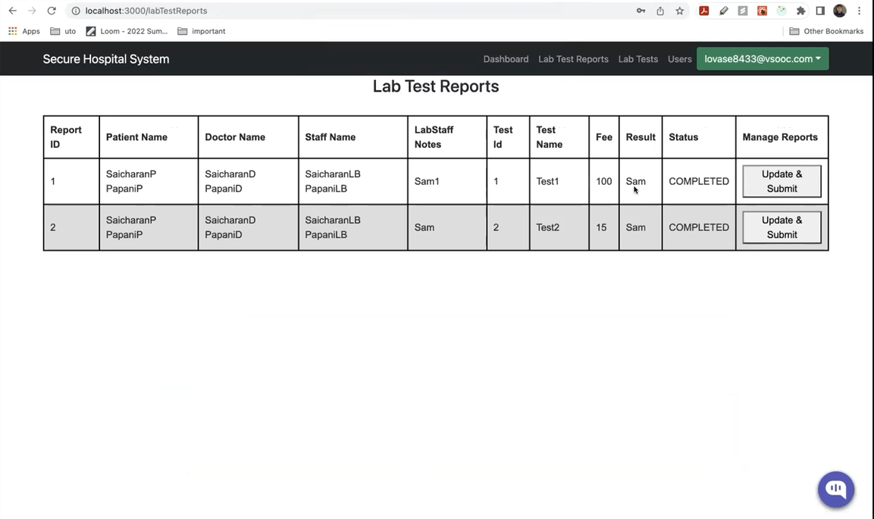
Figure 9: Approve/Deny Lab Test Reports
Writing Lab Reports: After clicking the update button on above page, they will be redirected to page below where they can update the details.
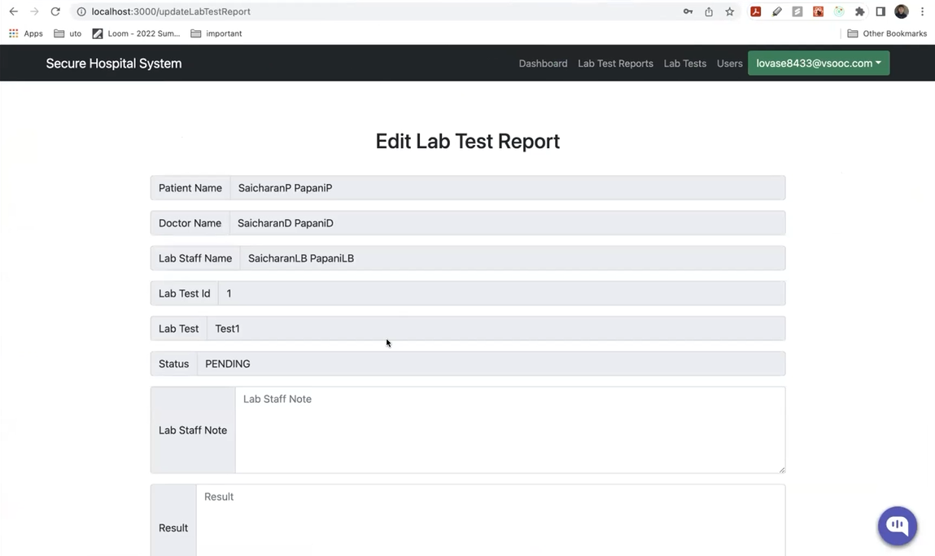
Figure 10: Edit Lab Reports
Create new Lab Tests: In this UI, the lab staff can view the existing lab tests as well as create new ones.
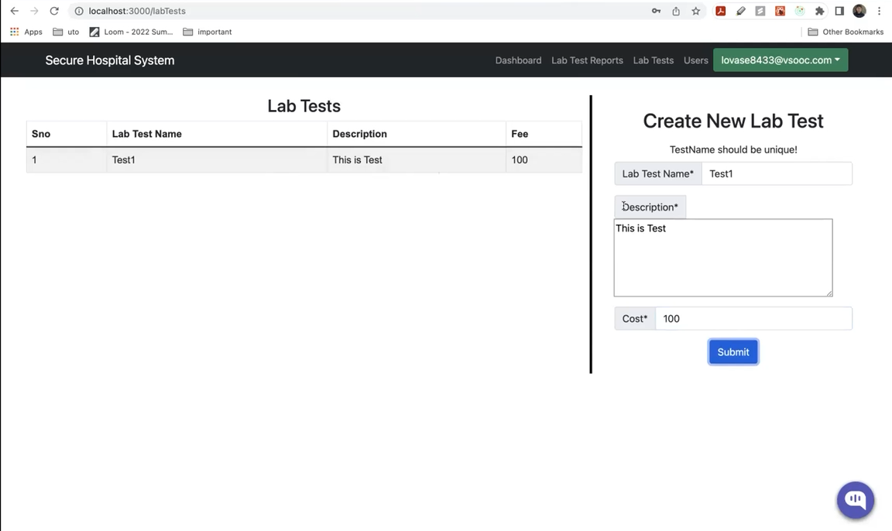
Figure 11: Lab Tests UI

INSURANCE STAFF
Insurance staff can create coverages, policies, approve/deny claims and check user diagnosis to check if claims are valid.
Create Coverage: Insurance staff can create coverages and also view existing coverages in same UI.
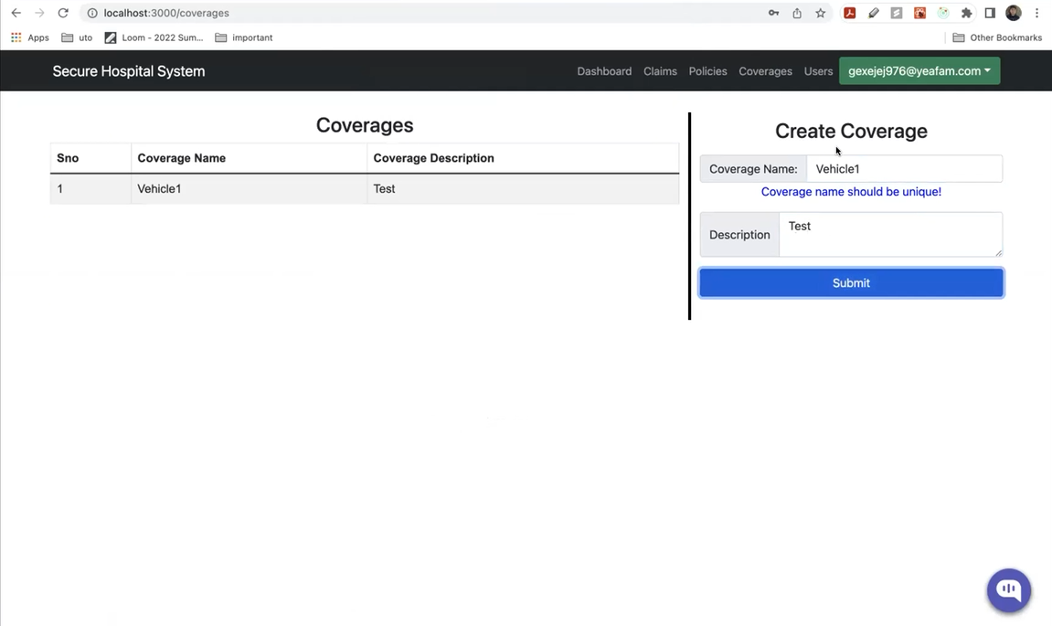
Figure 12: Coverage UI
Create Policies: Similar to coverages, they can create and view policies.
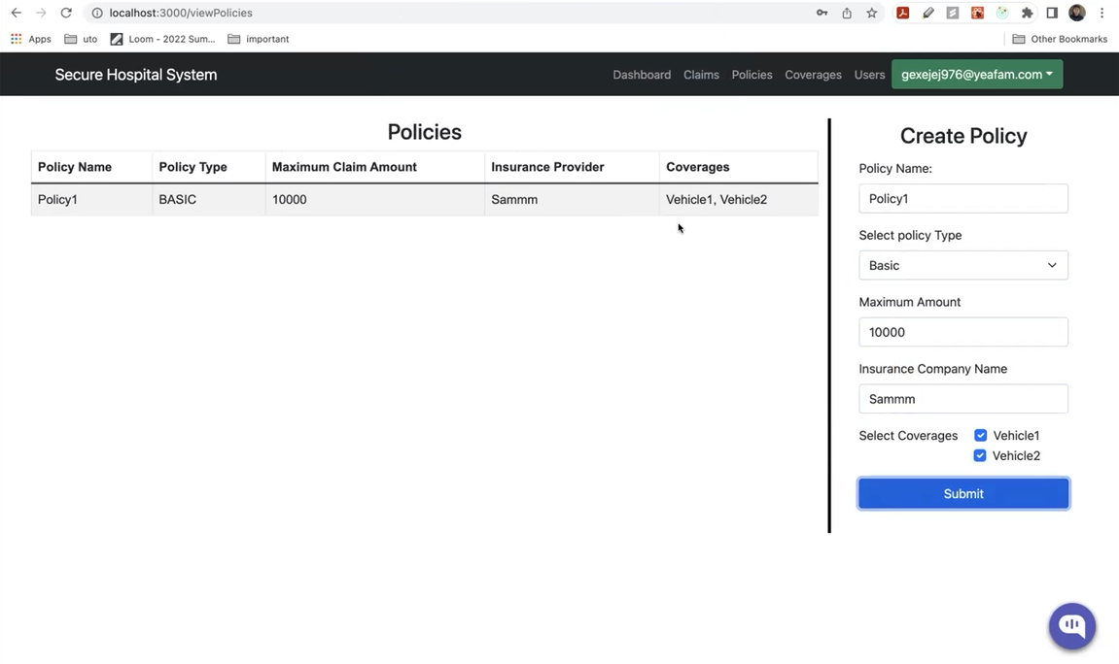

Figure 13: Policies UI
Approve/Deny Claims: Insurance staff can approve/deny the claims made by patients.
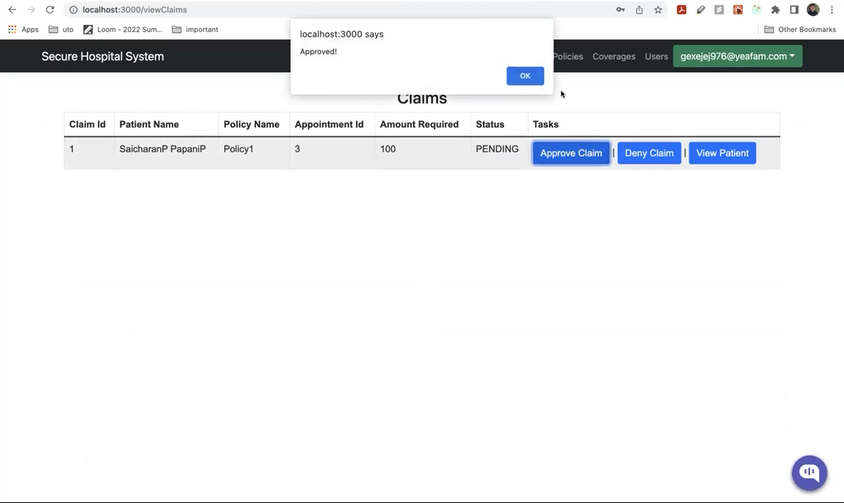
Figure 14: Approve/Deny Claims UI
View Patient Details: This page is accessible to Insurance Staff, Doctors and Hospital Staff for their own reasons as all of the data related to the patient can viewed here as shown in below screenshot.
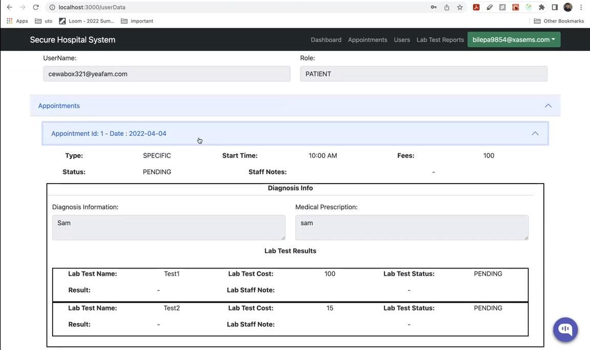
Figure 15: Patient Details

PATIENT
Patients can book appointments, raise claims, enroll in policies and pay bills.
Booking Appointments: Patients have the option to either book an appointment with specific doctor or just a generic appointment.
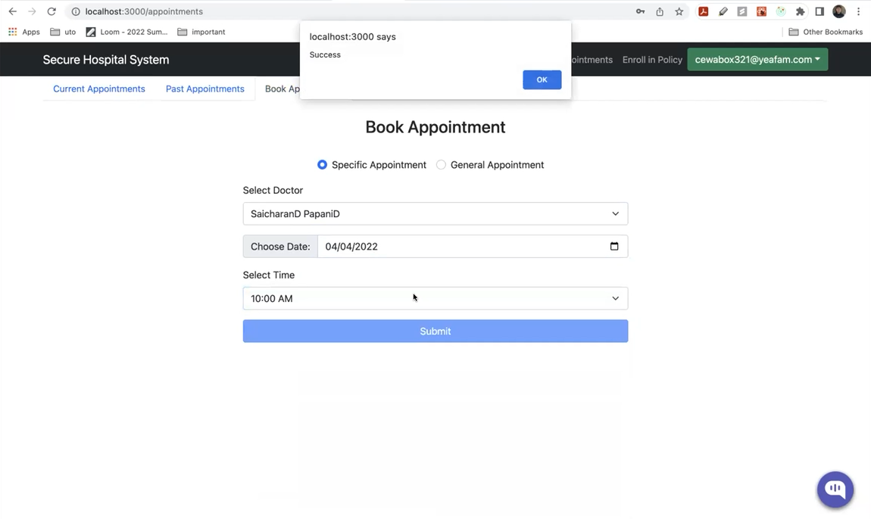
Figure 16: Booking Appointments
Enrolling in Policies: Patients can enroll in various policies provided by the hospital from the below UI.
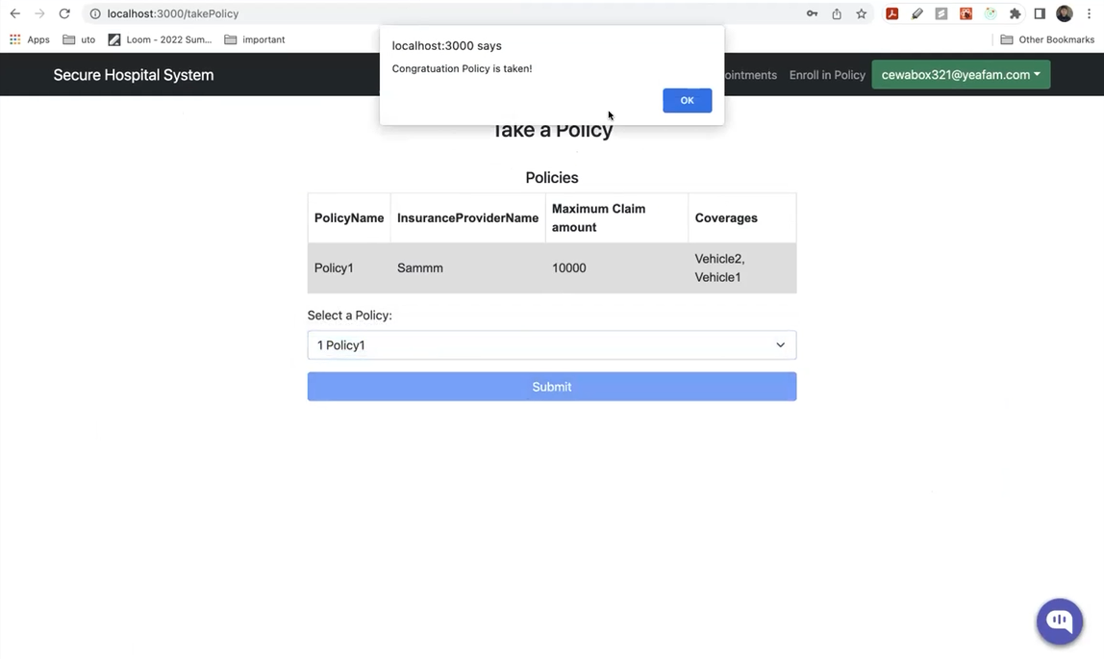
Figure 17: Enrolling in Policies
Raising Claims/Pay Bill: After an appointment is completed, the patient has an option to either pay the bill or raise a claim for the policies they have taken.
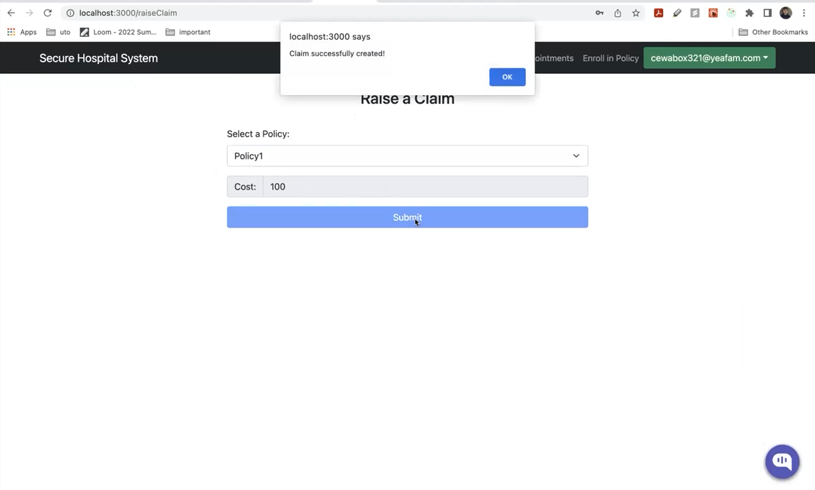
Figure 18: Raising a Claim
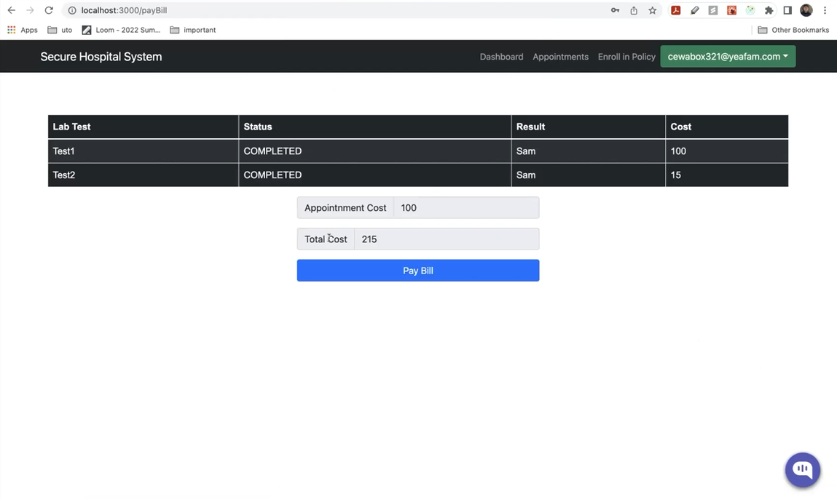
Figure 19: Paying Bill

CONTRIBUTIONS MADE BY ME
Backend Development
- Login logs implementation for Admins.
  - The backend implementation of logging all the users who are logging into the application and storing their date and time of login in the database.
- Lab Tests backend table and APIs.
  - The lab tests repository and the backend APIs like createNewLabTest and viewAllLabTests were created by me.
- Implemented DOB integration to the User table.
  - The initial design of User table didn’t have date of birth functionality which was later added by me.
Frontend Development
- Edit Account UI for all roles.
  - The UI to view and edit fields by clicking on account was implemented by me.
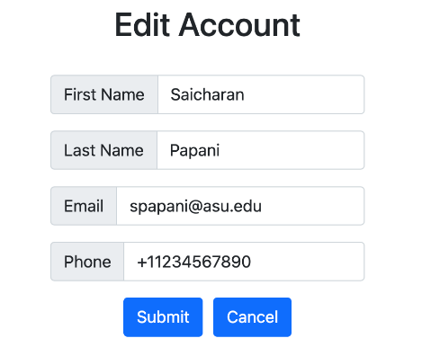
Figure 20: Edit Account
- Lab Tests functionality along with linking APIs with backend.
  - The UI, backend and linking of APIs was all done by me. (Figure 11)
- Various frontend UI including View all Transactions, Create User page and Pay Bill Page (Figures 8, 4 and 19) and Forgot Password were made by me.
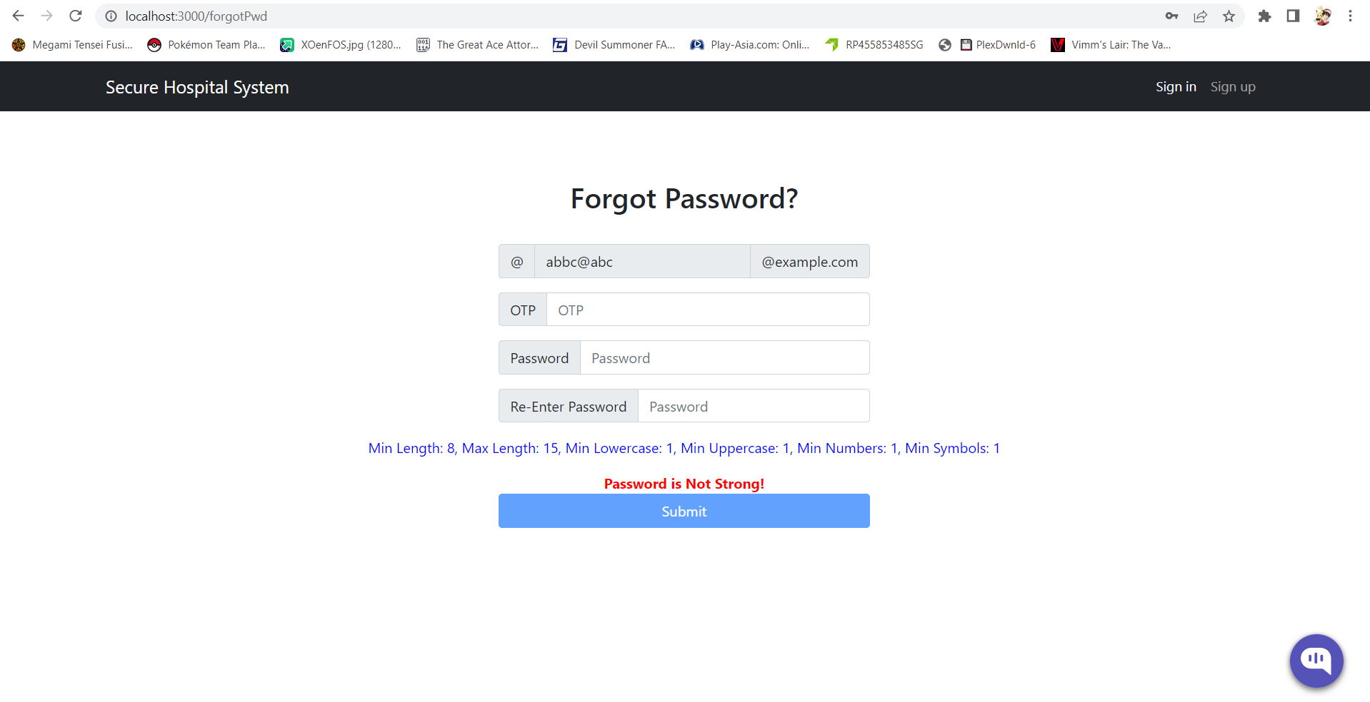
Figure 21: Forgot Password UI
General Contributions
- Weekly Reports were made by me which included in gathering the progress made by other members.
- Maintaining JIRA sprints which contained all the user stories as well as documenting Gantt charts.

LESSONS LEARNED
- How to work with the team and manage the team members (Team Management)
- Learnt basics of ReactJS and Spring Boot while doing development.
- Best practices of Agile methodologies.

